Setup And Instructions for Ferrocell with LED Ring
New! Includes LED controller. Connect between power supply and 4-pin connector. Tactile buttons change light colors and patterns.
Each LED is now RGB or W.
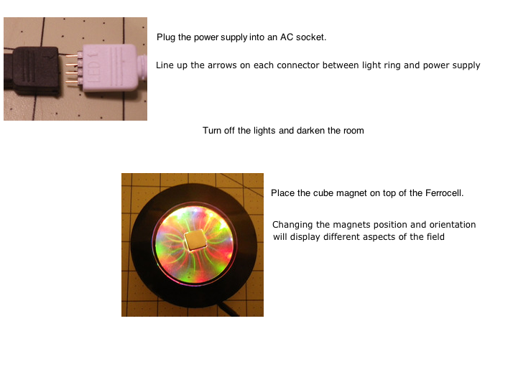 Wait 10-30 seconds for the image to manifest. Move magnets position often. Resting magnet in one position for long periods of time may burn the inside surface of the glass, creating a blurred view in the affected area.
